Game Design

Game Mechanics
The game mechanics describe the game play in detailed terms, starting with the vision of the core game play, followed by the game flow, which traces the player activity in a typical game. The rest is all the infinite details.

Core Game Play
The player pilots a small craft (Morito in nature) in a space-based environment avoiding obstacles and attacking enemies. Weapons can be found throughout the environment. The goal is to defeat your opponent through attacks that diminish their life total.

Game Flow
Traverse the environment looking for weapons, avoiding the terrain and attacking the enemy, until you deplete the enemies’ health, or your health is depleted.

Game Play Elements
This is a functional description of all elements that the player (or characters/units) can engage, acquire or otherwise interact with. These are such things as weapons, buildings, switches, elevators, traps, items, spells, power-ups, and special talents. Write a paragraph at the start of each category describing how these elements are introduced and interacted with.

Weapons include:

- Fan
  - Blows away all moveable objects, including projectiles and enemy ships, and our own ship.
- Armor Spike
  - Protects the ship by reducing the damage at the same location of the part, and cause damage to any enemy who runs into it. It can also be pushed out to cause damage to nearby enemies.
- Microwave laser
  - Heats up on object, causing damage to it, and possible giving it a burn damage over time. If an enemy runs into an object that is on fire they may become on fire, and the object may do additional damage.
- Remote mines
  - Fired slowly forward and is detonated by firing again.
- Proximity mines
  - Placed at the same location of the ship, and if an enemy enters a radius to proximity mine it detonates.
- Homing missiles
  - Homes into an enemy causing damage to that enemy.
- Lasso
  - Grabs on to an enemy and drags their ship according to where your ship goes.
- Springy boxing glove
  - Extends out past the ship, knocking it back and causing damage.
- Cannon
  - Knocks back an enemy ship and causes damage.
- Wall launcher
  - Launches walls to impede the enemies’ movement, and causing damage if the enemy runs into it at a fast enough speed.
- Harpoon
  - Launches a harpoon that pierces an enemy ship causing damage and knocking back the enemy and continues on through for a duration.
- Phase out machine
  - Allows the player to be invulnerable for a very short period of time.
- Gravity bomb
  - Shoots ahead of the player, exploding pulling all objects towards its centre and causing damage to any objects in the centre.
- Sword
  - Slices around the ship, simply causing damage.
- Mining drill
  - A player can latch on to objects and take health from them, including enemies. Will also remove the enemies weapon on that side.
- Nuke
  - Fires a bullet that explodes into a radius that causes damage initially and high damage over a short period of time in a radius.
- EMP bomb
  - Fires a bullet that explodes in a radius disabling parts of a ship or the entire ship.
- Remote control
  - Fires a remote that can cling to a ship, allowing intermittent control of the enemies ship when the user holds the fire button, for a duration and then the remote is destroyed and the weapon is reloaded.
- Baseball bat
  - Melee weapon that disorients enemy.
- Sticky goo
  - Can be fired often and stacks, slowing the enemy, and slowly depleting life, for a duration.
- TrickWeapon (lack of better name)
  - Can be dropped and if anyone goes near the weapon the weapon shoots the player. It takes on a random skin when dropped, and every time it flips around the screen. Either it takes up a slot for a player and doesn't attack that player, or it can also attack that player after it is dropped. It should probably be destroyable and on a time limit. Perhaps it should teleport every so often as a different weapon, and when it teleports in it'll have a different subtle effect to give away that it is a bad weapon.

Environmental Objects include:
- Walls
  - Obstructs players, and causes damage to players who approach this object at too fast of a speed.
- Floating debris
  - This can include real objects like signs, or asteroids, some can be destroyed, and others can’t. They have similar properties to Walls.
- Gravity wells
  - These draw in all objects. They may begin to orbit around the well.
- Shield wall
  - These allow ships to pass through them, but not hostile weapons.
- Explosive traps
  - These explode on contact or destruction. Red barrel.
- Spring boards
  - Objects bounce off these.
- Controlled structures
  - These objects have a pre-specified movement.
- Bizarro zones
  - These zones ‘cause strange effects like having a person fire in the opposite direction or fire a completely different weapon than what they have.
- Underwater zones
  - Projectiles with a large surface area travel slower here, including ships.
- Different atmosphere zones
  - Different effects of weapons in these zones. Like an area with air could have fire and gravity, while an area with clouds could allow higher damage electricity.

Game Physics and Statistics
Break out how the physics of the game should function, i.e. movement, collision, combat etc., separating each into subsections. Describe the look and feel and how they might vary based on statistics assignable to the characters, units and game play elements. Indicate the statistics required to make them work. Get feedback from the programmers as you write this, as how the game handles the physics and the quantity of the statistics will severely impact performance issues.
This can get a little dry, but avoid getting too technical. Avoid using actual numbers or programming terms. These will come later in the technical specification, written by the programmers who will want to do things their way (usually the right way). Just tell them what you want to accomplish. For example: "The units should slow down when going up hill and speed up when going down, unless they are a hover or flying vehicle. How much they are affected should be a factor of their climbing and acceleration statistic as well as the angle of the incline." You would not tell the programmers what math to use to adjust the speed. Assuming you are not a programmer yourself, they’re just better at that than you.
[NEW]
Movement:
The ships can accelerate both foward and backwards with the user of thrusters. It can also turn at a consistent speed. Asteroids have an initial random trajectory and do not accelerate or decelerate unless another object collides with it. Every other object will either stay stationary or move at a constant speed like the asteroids, unless their definition states otherwise.
Collision:
All object will collide in the same consistent manner, similar to the laws of euclidean physics. Weight, force and velocity all have a factor in how objects collide. Some objects may have special properties that circumvent the normal collision, however this is rare, as force, weight, and velocity should usually be the only dynamic factors.
Combat:
Being the main purpose of the game this is best defined by the weapons list in the Game Play Elements section, however every ship will normally have a default weapon that does basic damage. Although the end goal is to deplete your enemies health to zero, their are more methods to damage an opponent than shooting a weapon directly at them, including using the environment against them.
Health and Respawn:
Every players, and most objects will have a set amount of health. When that health is depleted they will be penalized, but respawn until the end of their part in the game. Respawning will give the player a set amount of health back and allow them to play again.

Artificial Intelligence
Describe the desired behaviour and accessibility of the AI in the game. This includes movement (path finding), reactions and triggers, target selection and other combat decisions such as range and positioning, and interaction with game play elements. Describe the avenue through which the AI should be controlled by the level designers, i.e. using .INI files, #include files of game stats or C-code, proprietary AI scripts, etc.
[NEW]
This is currently not an issue for our game.

Multiplayer
Indicate the methods of multi-player play (i.e. head-to-head, cooperative vs. AI, teams, every man for himself, hot seat) and how many players it will support on the various networking methods. Describe how multi-player differs from solo-play in game flow, characters/units, game play elements and AI.
[NEW]
Multiplayer is the cornerstone of our game. The game will initially support 2 players attempting to deplete each others health. In the end we plan to have 4 players on one machine be able to battle it out, and support the same through both a LAN connection on PCs and Xbox live.
Their will be a large number of options the player can choose for the multiplayer game. These options may include level, game type, time, respawn time, weapons available, weapon spawn rates, environment objects available, environment object spawn rates, and potentially more.

User Interface
The interface changes so very often that it almost seems pointless to document it; however, it’s got to start somewhere. It’s structured here to minimize the impact of changes. It’s starts with a flowchart of the screen and window navigation, and then breaks down the functional requirements of all the screens and windows. That done, the GUI artist is free to do what he or she feels is right as long as it meets the requirements. To get him or her started you should provide mock-ups. This often is to the designer’s benefit to think everything through. Then follow up with a description of all the GUI objects that need to be programmed to make all the screens work.
[NEW]
Their are generally two screens the user needs to worry about. The menu and the game its self. At any time during the game the player can access the menu, pausing the game. The interface is controlled using up, down, left, right, confirm and cancel, so that the usability is the same for controller users as it is for keyboard users.
We should probably sketch out the interface of Morito while playing, for things like health, and ammo and such.

Flowchart
[NEW]
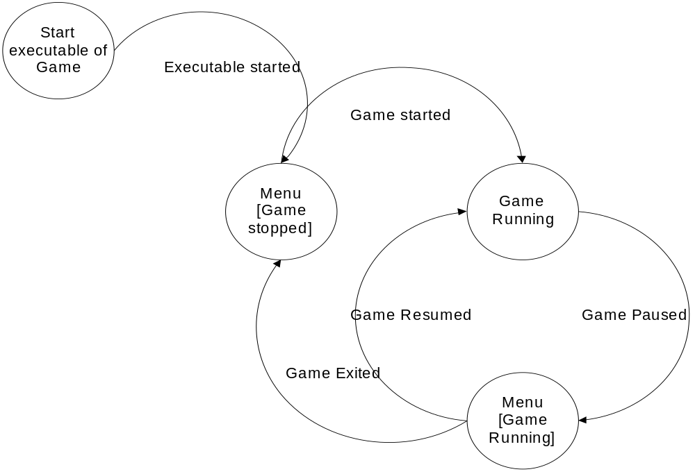

Functional Requirements
This functional breakdown of every screen, window and menu lists the user actions and the desired results and may include diagrams and mock-ups. While the specific interaction (buttons, hotspots, clicks, drags and resulting animations) can be listed, it’s often best to keep this separate from the list of functional requirements as these can evolve during implementation. Of course if it’s just easier to think in terms of clicking a button or it’s really important that something work a certain way, then by all means get specific about the method of interaction.

Mock-ups
Create a mock-up for all the screens, windows and menus. This may end up getting ignored, but it’s a good starting point for the artists if they have no idea what else they may want to do. Don’t waste your time creating anything really pretty. Just create simple line drawings with text labels. Color can be very distracting if it’s bad, but if it’s important, go ahead. Some drawing programs have templates that make creating mock-ups very quick and easy.
///TODO

GUI Objects
These are the basic building blocks used to create all the screens, windows and menus. This should not include the items seen in the main view portal, as these are covered in the art list in the next section. The GUI objects are primarily listed here for the programmers to know what pieces they’ll need to code and have for putting together the screens. You should explain in detail how each is interacted with and how they behave. It may seem a bit obvious and not worth documenting, but it really helps when drafting together the technical spec and schedule to know exactly everything the game will need.
For some games, this can be a very quick list to put together – buttons, icons, pointers, sliders, HUD displays etc. But it’s much more complicated in games where the interface is at all different. However, keep in mind that the methods of interaction are not all that different. A button is still a button, even if it’s clicking on a gorgon’s head instead of a grey rectangle.
[NEW]
Main Menu -> Play Game: starts a new game
-> Options: insert more detail
-> Exit -> Prompt -> Confirm: exit executable.
-> Cancel: return to Main Menu.
///TODO: add gui objects from while the player is playing the game.

Art and Video
This should be the definitive list for all the art and video in the game. We all know how things creep up, though, so add a couple of placeholder references for art to be named later, like mission specific art and art for marketing materials, demos, web pages, manual and packaging.
///TODO

Overall Goals
This is where you should spell out the motifs, characteristics, style, mood, colors etc. that make up the goals for the art. Gather consensus with the lead artists and art director and make sure they see eye to eye with the project’s director or producer. Doing so now will save a lot of time later if they end up redoing everything because the goals were never clearly defined.
This is a non-issue for our simple game. [If anyone has an issue, then please bring it up with Jason, and we'll talk about it]

2D Art & Animation
This is really just a huge list that can be thrown into the art schedule. It can also include descriptions if needed. Some art isn’t self-explanatory, and other may involve specific needs from a design standpoint. Be sure to explain it all. Break your art down into sections. The lead artist may have some particular way he or she would like you to do that. I’ll list the typical section and their contents. Read them all to be sure you don’t forget anything.
///TODO, mostly includes splash screens and menu.

Marketing and Packaging
You might as well list it here and the schedule, because they’ll ask for it. This includes web page art, sell sheet design, demo splash screens, magazine adds, press art, the box and manual.
///TODO or leave out?

Special Effects
Salvo, explosions, sparks, footprints, blood spots, debris, and wreckage.
///TODO

3D Art and Animation
This serves the same purpose and has the same requirement of the 2D Art list above. The difference may be in how the work may be divided. Art teams like to divide 3D art task lists into models, textures, animations and special effects, as they usually divide the tasks this way to maximize talent and skill and maintain consistency.
///TODO

Cinematics
We have no plans to have any cinematics.

Sound and Music

Overall Goals
Stress the aesthetic and technical goals for the sound and music. Describe the themes or moods you want. Name existing games or films as examples to aspire to. Issue technical edicts and editing objectives, such as sampling rates, disk space, music formats, and transition methods.
///TODO

Sound Effects
List all the sound FX required in the game and where they will be used. Include the intended filenames, but be sure to consult with the sound programmer and sound technician (or composer) on the file naming convention. This makes it easier for people to find the sound FX and fold them into the game.
Don’t forget about all the areas that sound FX may be used. You don’t want to overlook anything and throw off the schedule. Go through all the game elements and your art lists to see if there should be some sound associated with them. Here are some to consider:
///TODO

GUI
Button clicks, window opening, command acknowledgments.
///TODO

Special Effects
Weapons fire, explosions, radar beeping.
///TODO

Characters
Voice recordings, radio chatter, stomping, collisions.
///TODO, starfox? :D

Game Play Elements
Pick-up jingle, alerts, ambient sounds.
///TODO

Terrain (Environment)
Birds, jungle sounds, crickets, creaks.
///TODO

Motion
Wind, footfalls, creaking floors, wading, puddle stepping.
///TODO

Music
List all the music required in the game and where it will be used. Describe the mood and other subtleties. Music will often reuse the same themes and melodies. Mention where these themes should be reused. Consult the composer on this.

Event Jingles
Success, failure, death, victory, discovery, etc.
///TODO

Shell Screen
Mood setting for title screens, credits, end game.
///TODO

Level Themes
Level specific music (designers choose the theme).
///TODO

Situations
Sets the mood for situations (lurking danger, combat, and discovery).
///TODO

Cinematic Soundtracks

Story
We have none.

Level Requirements

Level Diagram
We can list our goals of the different types of maps we would like to see.
///TODO

Asset Revelation Schedule
This should be a table or spreadsheet of what level the game’s assets are to be revealed to the player for the first time. There should be a row for each level and a column for each general type of asset. Assets include power-ups, weapons, enemy types, tricks, traps, objective types, challenges, buildings and all the other game play elements. The asset revelation schedule ensures that assets, the things that keep the players looking forward to the next level, are properly spaced and not over or under used.
///TODO. Do we want some type of unlock system?

